**PIZZA SALES SQL QUERIES**

----1. Calculating the Total Revenue

SELECT SUM(total_price) AS Total_Revenue

FROM PIZZA;

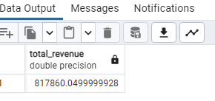

----2. Average order made

SELECT SUM(total_price)/ Count(distinct order_id) as Avg_Order

FROM PIZZA;

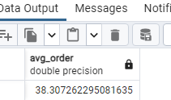

----3. Total pizza sold

SELECT SUM(quantity) AS Total_Pizza_Sold

FROM PIZZA;



----4. Total orders made

SELECT Count(distinct order_id) AS Total_Pizza_Sold

FROM PIZZA;

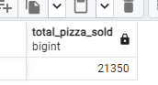

----5. Average pizza per order

SELECT Cast (Cast (SUM(quantity) as decimal(10,2))/ Cast (Count(distinct order_id) as decimal(10,2)) as Decimal(10,2)) as Avg_pizzaperorder

FROM PIZZA;

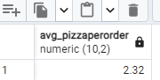

---- 6. Daily trend for orders

SELECT TO_CHAR(order_date, 'Day') as Order_days,

COUNT (DISTINCT order_id) as Total_Orders

FROM PIZZA

GROUP BY TO_CHAR(order_date, 'Day');

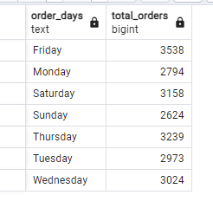

-----7. Monthly trend for orders

SELECT TO_CHAR(order_date, 'Month') as Month_Name,

COUNT (DISTINCT order_id) as Total_Orders

FROM PIZZA

GROUP BY TO_CHAR(order_date, 'Month')

ORDER BY Total_Orders desc;

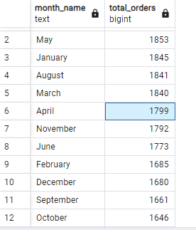

----8. Percentage of sales by categories of pizza and total Revenue

SELECT pizza_category,

Cast (SUM(total_price)as decimal(10,2)) AS Total_Revenue,

Cast (sum(total_price)*100/(SELECT SUM(total_price) From PIZZA)as decimal(10,2)) AS PCT

FROM PIZZA

GROUP BY pizza_category

ORDER BY PCT DESC;

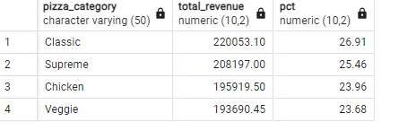

----9. Percentage of sales by size of pizza and Total revenue

SELECT pizza_size,

Cast (SUM(total_price)as decimal(10,2)) AS Total_Revenue,

Cast (sum(total_price)*100/(SELECT SUM(total_price) From PIZZA)as decimal(10,2)) AS PCT

FROM PIZZA

GROUP BY pizza_size

ORDER BY PCT DESC;

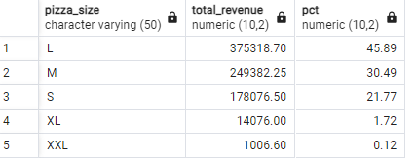

----10. Percentage of sales by size of pizza for Second Quarter and Total revenue

SELECT pizza_size,

Cast (SUM(total_price)as decimal(10,2)) AS Total_Revenue,

Cast (sum(total_price)*100/(SELECT SUM(total_price) From PIZZA WHERE EXTRACT(QUARTER FROM order_date) = 2)as decimal(10,2)) AS PCT

FROM PIZZA

WHERE EXTRACT(QUARTER FROM order_date) = 2

GROUP BY pizza_size

ORDER BY PCT DESC;

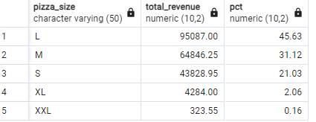

----11. Top 5 Best sellers by Revenue

SELECT pizza_name, SUM(total_price) AS Total_Revenue

FROM PIZZA

GROUP BY pizza_name

ORDER BY Total_Revenue DESC

LIMIT 5;

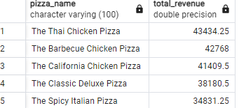

----12. Bottom 5 sellers by Revenue

SELECT pizza_name, SUM(total_price) AS Total_Revenue

FROM PIZZA

GROUP BY pizza_name

ORDER BY Total_Revenue ASC

LIMIT 5;

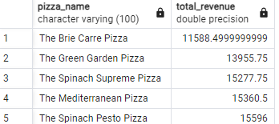

----13. Top 5 Best sellers by Total_Quantity

SELECT pizza_name, SUM(quantity) AS Total_Quantity

FROM PIZZA

GROUP BY pizza_name

ORDER BY Total_Quantity DESC

LIMIT 5;

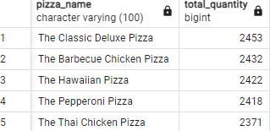

----14. Bottom 5 sellers by Total_Quantity

SELECT pizza_name, SUM(quantity) AS Total_Quantity

FROM PIZZA

GROUP BY pizza_name

ORDER BY Total_Quantity ASC

LIMIT 5;

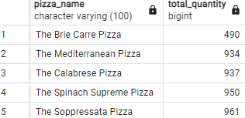

----15. Top 5 Best sellers by Total orders made

SELECT pizza_name, Count(distinct order_id) AS Total_Pizza_Sold

FROM PIZZA

GROUP BY pizza_name

ORDER BY Total_Pizza_Sold DESC

LIMIT 5;

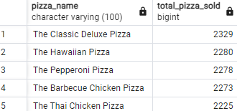

----16. Bottom 5 sellers by Total orders made

SELECT pizza_name, Count(distinct order_id) AS Total_Pizza_Sold

FROM PIZZA

GROUP BY pizza_name

ORDER BY Total_Pizza_Sold ASC

LIMIT 5;

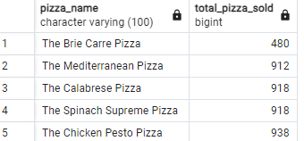

---- 17. Top 5 by combined Revenue, Quantity, total orders

SELECT pizza_name,

SUM(total_price) AS Total_Revenue,

SUM(quantity) AS Total_Quantity,

COUNT(DISTINCT order_id) AS Total_Pizza_Sold

FROM PIZZA

GROUP BY pizza_name

HAVING SUM(total_price) >= 30000

AND SUM(quantity) >= 2000

AND COUNT(DISTINCT order_id) >= 2000

ORDER BY Total_Revenue DESC

LIMIT 5;

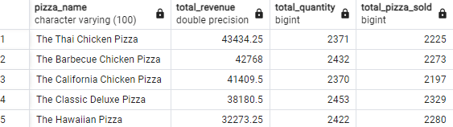

---- 18. Bottom 5 by combined Revenue, Quantity, total orders

SELECT pizza_name,

SUM(total_price) AS Total_Revenue,

SUM(quantity) AS Total_Quantity,

COUNT(DISTINCT order_id) AS Total_Pizza_Sold

FROM PIZZA

GROUP BY pizza_name

HAVING SUM(total_price) <= 16000

AND SUM(quantity) <= 1000

AND COUNT(DISTINCT order_id) <= 1000

ORDER BY Total_Revenue ASC

LIMIT 5;

